PREPARATION
Front Entrance Fountain
- Make sure space heater is on
- Make sure light is on in between standpipe and well house.
Buffet
- Turn off water to restrooms in the salt area
- Disconnect toilets and open hose valves in walls
- You must blow the lines out
- Turn on heaters in restrooms if you want to keep water on (still risky)
- 2 space heaters in back kitchen area
- Make sure kerosene torpedo heater is in working order and kerosene on hand (heater will use about 10% a day to keep at 50 degrees when temps are between -10 and 20 degrees)

Carpenter Shop in Marketplace and East Gate
- Turn faucet on drip
- Make sure heater is running in carpenter shop
- Turn off is behind Jerusalem Chapel underneath large wooden pail
- Turn off is in East Jerusalem Gate elevator shaft for East Gate upstairs as well as Holy Land Tour monument

Basement Chapel
- Drip faucet in restroom
- Put small space heater in restroom
Bethlehem Inn
- Drip faucets
- Make sure space heater is aimed into bathroom and exhaust fan/light is off (to keep heat in)
- Downstairs in electrical panel room the shower trap will freeze unless there is a light right on it or a space heater
Main Gift Shop Restroom – Women’s
- Make sure heat is on women’s restroom
- Put space heater on in women’s room if necessary
- Make sure end faucets are dripping both hot and cold water
- Underneath in Plumber room crawl space
- Turn on lights
- Turn on space heater

Main Gift Shop Restroom – Men’s
- Heat is connected to main gift shop
Main Gift Shop – Boy’s Dorms and Showers
- Turn off hot water out at hot water heater
- Turn off cold water above hot water heater (where it transitions from pipe to pex)
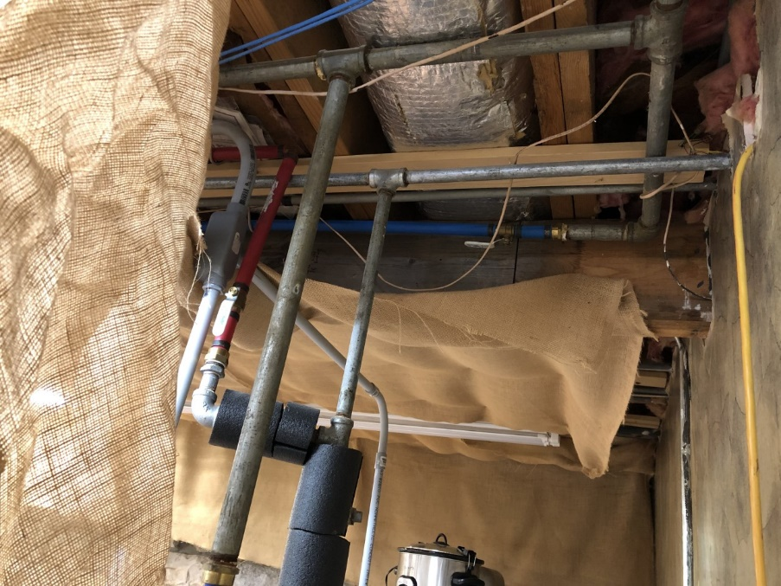
- Drain will freeze in extremely cold weather. DO NOT TRY AND KEEP OPEN.
- Drain showers and sink.
Well House and Pump House
- Make sure heat lamp is on in well house
- Make sure space heater is on in pump house

Statue Restrooms
- Make sure 2 space heaters are on in the rear area of statue restrooms
- Drip faucets on each side
- Heat lamp in the valve area behind the restrooms

Laundry Room – Lower RV Park Area
- Make sure split unit is working
- Make sure space heater with thermostat is by water heater
- Drip both hot and cold water from sink
- Shut off valve is in middle of building with short railroad tie
- Drain is at end of building on same side of valve.
RV Park Area
- People will try and keep their hoses on, but water will only last for about an hour in extreme cold.
- DO NOT LET PEOPLE TRY. Drains will also freeze.
- Frost frees must have heat tape and hoses must be heated as well.
- Watch for splitters and hoses left on bibs. Nothing must be on frost frees for them to work properly.
Maintenance Shop
- Make sure you have enough propane on hand (about a week before extreme cold expected)
- Drip both bathroom and shop faucets
- Space heater is upstairs and would benefit from small space heater
- Make sure heat is on in office and “exhaust” heat fan is on for restroom.
Set
- Make sure room below temple has heater and light on. (light switch controls power for light and wall heater)
- Make sure to drip old baby sitting room shower and sink.
- Wall heater must be working in babysitting room.
- Set room 1 and 3
Drip sinks and make sure doors to Room 1 and 3 restrooms are open.
Make sure hoses are disconnected at frost free behind cross area
Double check pyro room temperatures if you have a lot of pyro

Administration Building
- Shower drain will freeze with very cold temps
- Drip faucet in art storage area and keep cabinet doors open
- Make sure no hose is attached outside
- Keep doors open to restrooms and cabinets as well
- Drip employee restroom faucet
Snack Shop and Bathrooms
- Already winterized
Play Concession Stand/Blanket Room
- Already Winterized
Holy Land
- Already winterized
Ticket Office and Flagpole Bathrooms
- Already winterized

First Aid Room
- Already winterized

Sacred Arts Boys Dorm
- Already winterized

DAILY CHECKLIST (this takes 1-2 hours and
needs to be done in the morning and in the evening.
- Front Entrance Pump House
- Buffet (keep an eye on walk in refrigerator and freezers maintain operate temps as well
- Eastern Gate elevator shaft and Marketplace Restroom
- Basement Jerusalem Chapel
- Bethlehem Inn inside and basement
- Main Gift Shop Restrooms and Basement
- Well House and Pump House
- Statue Restrooms
- Laundry – Lower RV Park
- RV Areas
- Maintenance Shop
- Set
- Barn
- Administration Building

